Context-Aware Power LLM Agent Skill for Knowledge-Mask Generation
The preceding section constructs a structured input context, denoted as . However, this context cannot be directly used as an action constraint. Therefore, this paper further proposes a context-aware Power LLM Agent Skill to convert into a knowledge-enhanced mask. This module does not directly generate dispatch actions. Instead, it determines whether each controllable resource in the action space should be activated under the current contingency scenario.
Given the structured context , the Power LLM Agent Skill is formulated as follows:
where denotes the set of reinforcement learning action resources, denotes the training-stage or policy-state indicator used for reasoning-mode selection, is the preliminary mask generated by the LLM, and represents the corresponding reasoning evidence.
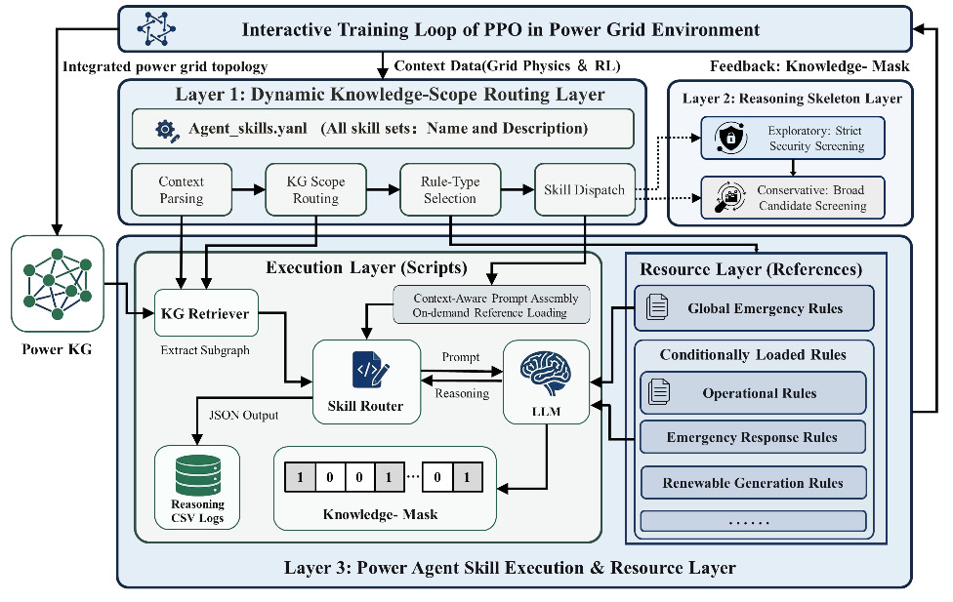
Fig. 3. Hierarchical architecture of the context-aware Power LLM Agent Skill for knowledgemask generation.
As shown in Fig. 3, the Power LLM Agent Skill adopts a three-layer architecture comprising a dynamic routing layer, an instruction skeleton layer, and an execution resource layer. This architecture converts the structured context into a knowledge-enhanced mask.
The dynamic routing layer determines the knowledge scope and category of dispatch rules required for the current reasoning process based on the contingency state, overload information, and candidate controllable resources contained in . This layer focuses subsequent reasoning on information relevant to the current grid operating condition.
The instruction skeleton layer selects the reasoning skeleton according to the training-stage or policy-state indicator . Different from a simple preference setting for LLM generation, the skeleton specifies the resource-eligibility checking logic used in mask generation. In this study, two predefined skeletons are considered:
The exploratory skeleton is used to retain more candidate controllable resources during early training or relatively low-risk operating states, whereas the conservative skeleton is used to strengthen security rules, dispatch-rule evidence, and resource-activation priorities under severe overload conditions, late-stage policy refinement, or abnormal mask-generation cases.
The execution resource layer integrates contingency-related knowledge and dispatch-rule information to assess the eligibility of controllable resources for the action space. It outputs a binary knowledge mask with the same dimension as the reinforcement learning action space. Meanwhile, this layer records key rule bases and judgment results, thereby forming traceable evidence of reasoning.
Through the three-layer architecture, the Power LLM Agent Skill progressively converts the structured context into resource availability judgments aligned with the action space. The dynamic routing layer identifies the relevant knowledge scope under the current scenario. The instruction skeleton layer constrains the discriminative logic of the reasoning process. The execution resource layer then maps the reasoning results to the action dimensions of specific controllable resources. Therefore, the output of the LLM is not an open-ended dispatch recommendation, but a knowledge-enhanced mask aligned with the reinforcement learning action space.
During knowledge mask generation, the Agent Skill performs resource-level eligibility reasoning for each action resource . This reasoning process does not determine the specific magnitude of the regulation. Instead, it evaluates whether resource is eligible to participate in post-contingency power flow regulation. This process is expressed as.
where indicates whether resource belongs to the candidate controllable resource set selected by the knowledge subgraph; indicates whether the resource still has sufficient regulation margin; and indicates whether the resource satisfies the currently loaded dispatch rules. When all three conditions are satisfied, , and the resource is retained in the action space. Otherwise, , and the resource is masked by the knowledge mask.
To reduce uncertainty in natural-language outputs, format consistency and action-space alignment are further checked for . Specifically, the alignment function verifies whether the output of the LLM can be parsed as a valid vector in , and ensures a one-to-one correspondence between each mask element and each resource in the action resource set :
Here, denotes the default fallback mask, which can be set as an all-one vector to prevent abnormal LLM outputs from completely blocking the action space.

